FRAMA C – BASIC CODES

-Richa Vivek Savant

BL.EN.U4CSE21171

1. Maximum function with precondition and postcondition

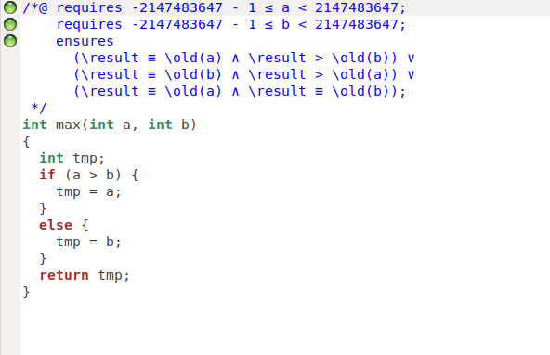

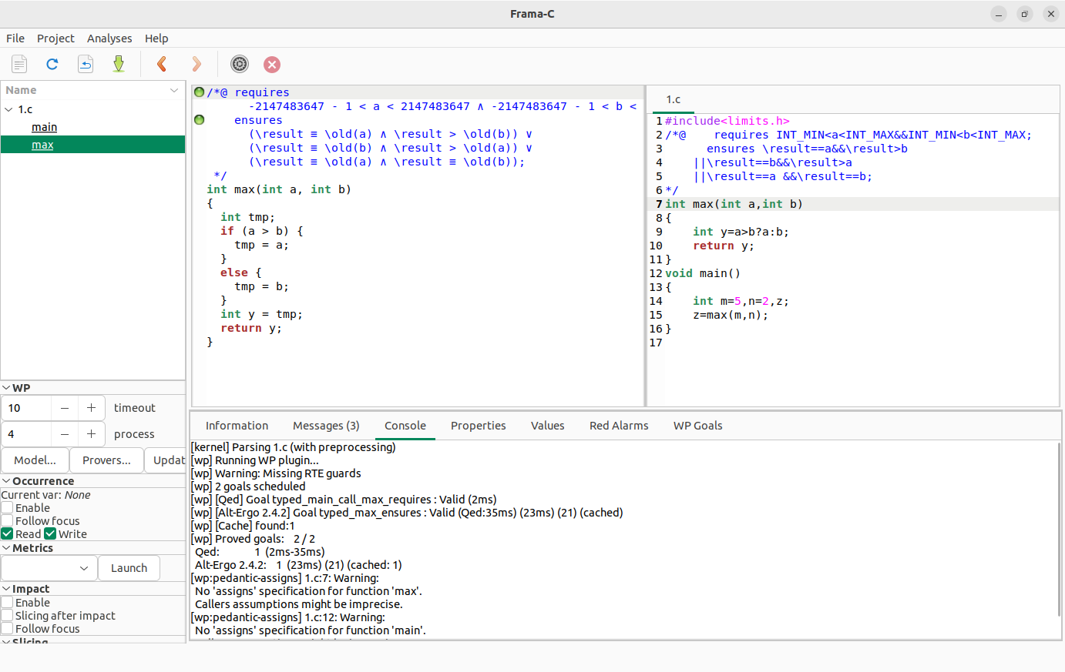

2. Increment function with precondition and postcondition.

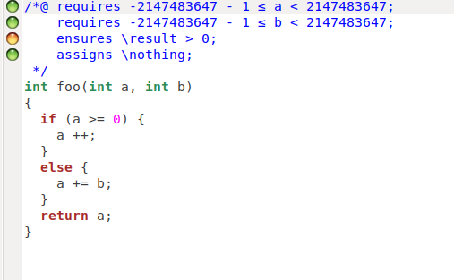

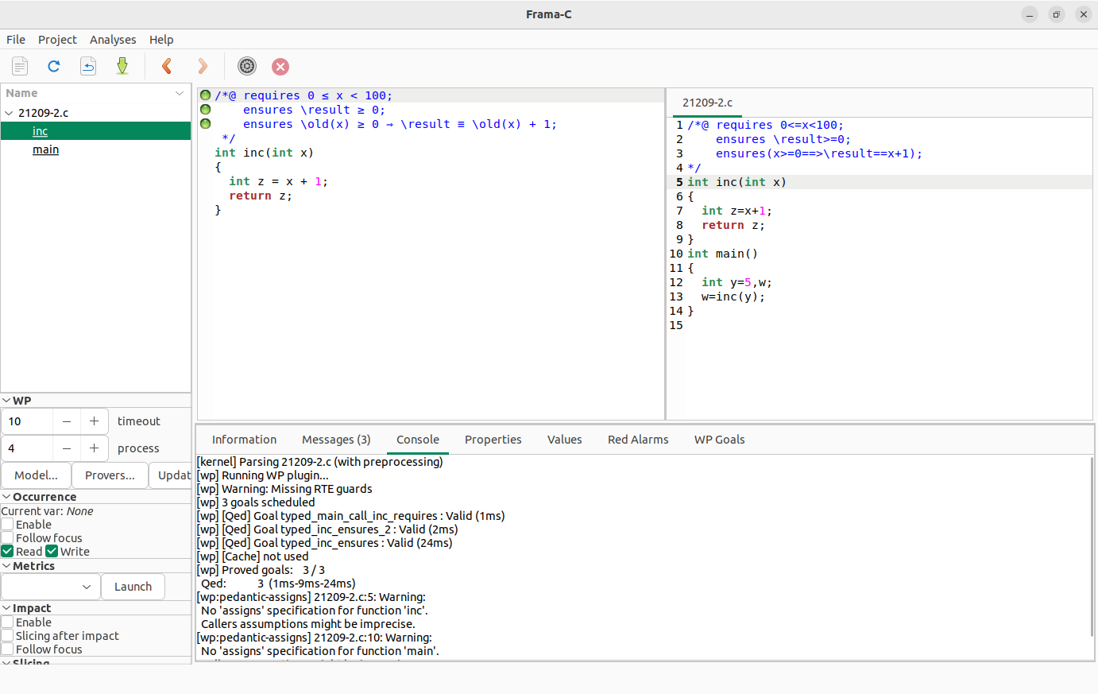

3. Compute the absolute value without arithmetic overflow and with precondition and postcondition.

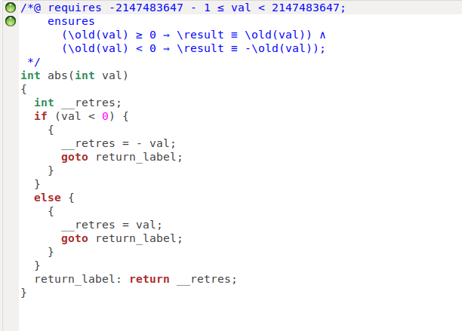

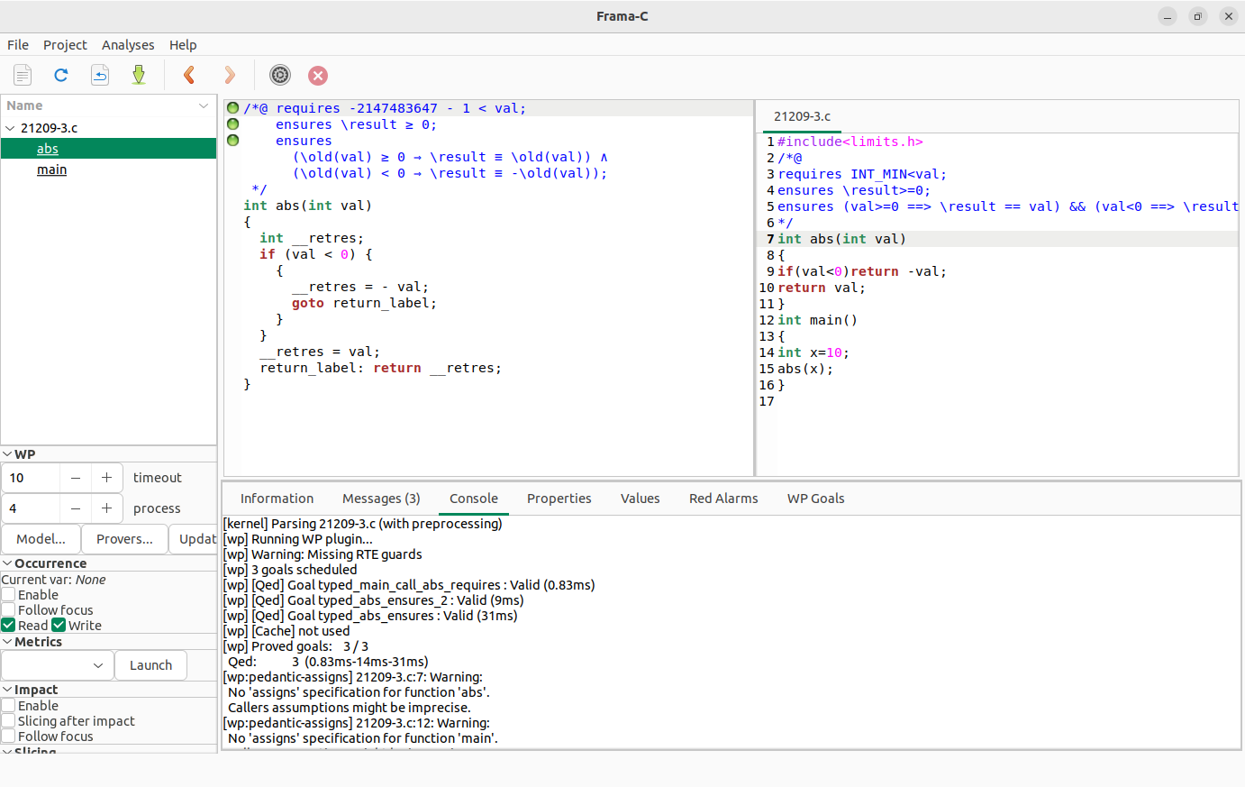

4. To check the given no. is odd or even, Divisible by 3 or not with precondition and postcondition.

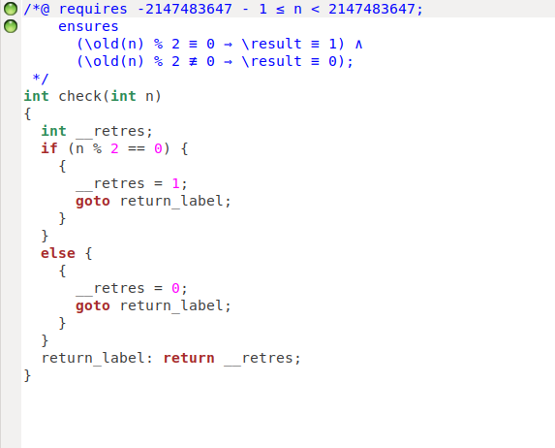

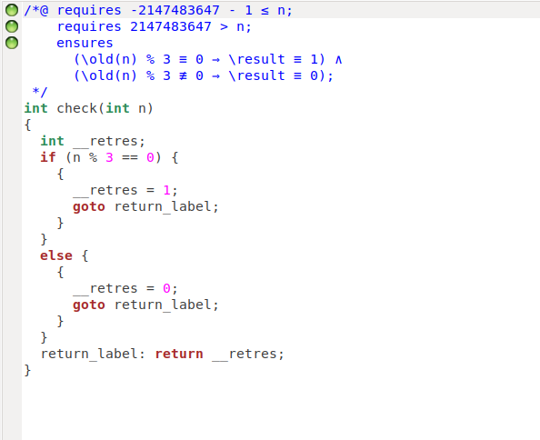

5. Swap function using pass by value with precondition and postcondition.

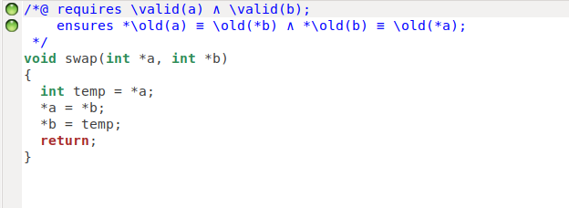

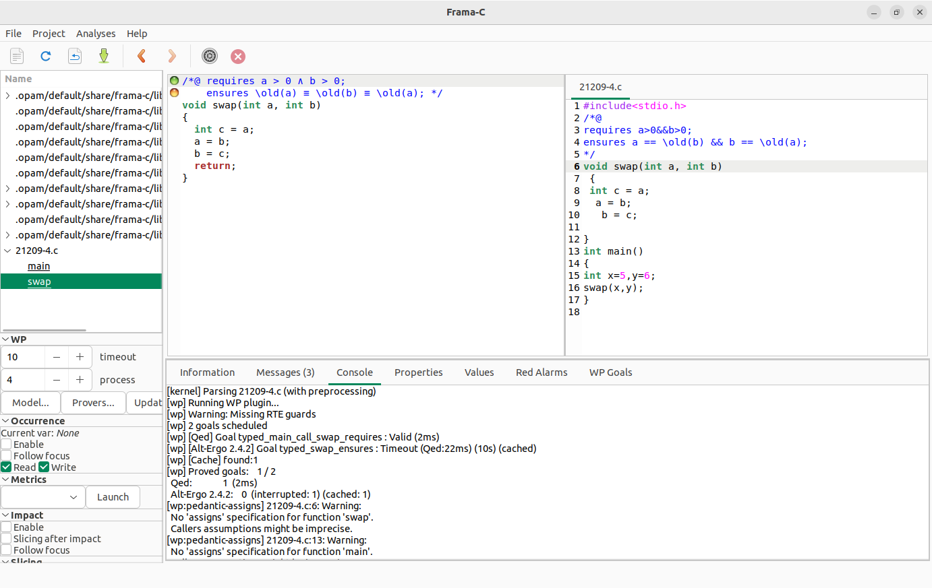

6. Swap function using pass by reference with precondition and postcondition.

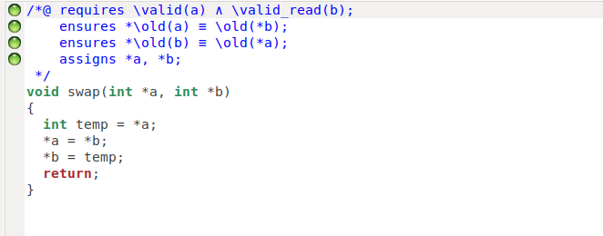

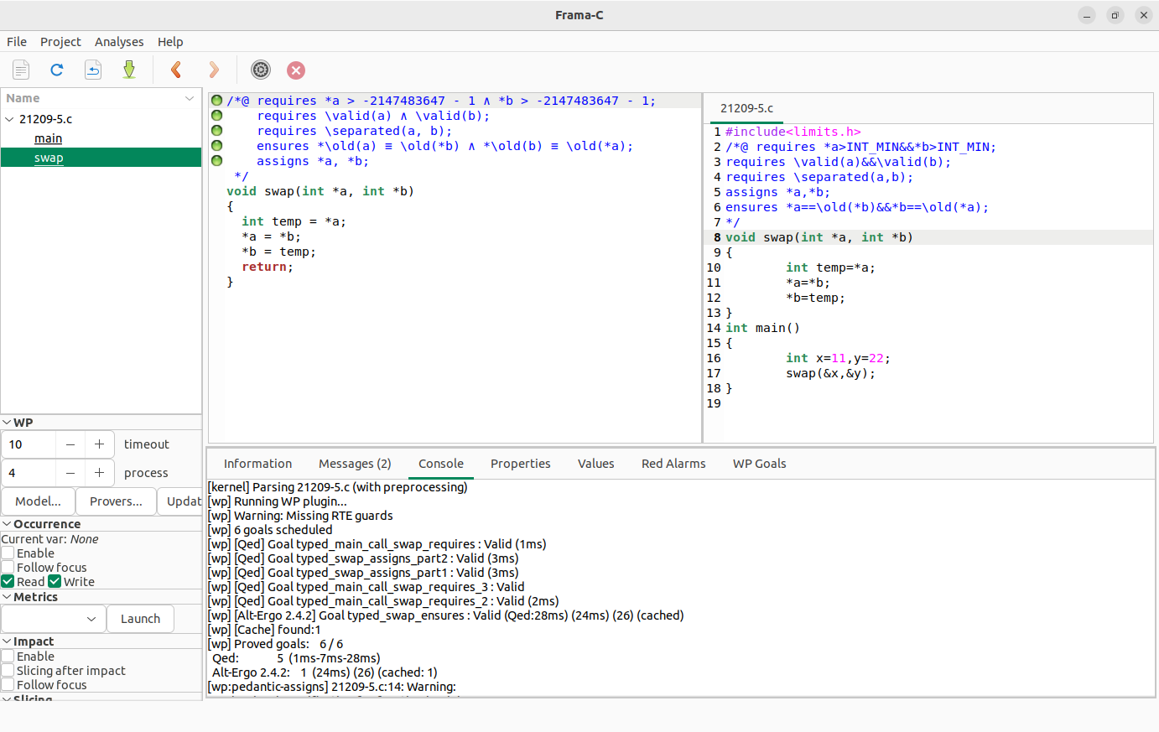

8. Computing the integer square root with precondition and postcondition.

